<https://paperswithcode.com/datasets>

<https://www.dataquest.io/blog/free-datasets-for-projects/>

**DATA PRE-PROCESSING**

**DATA NORMALIZATION**

**How to normalize data to 0-1 range?**

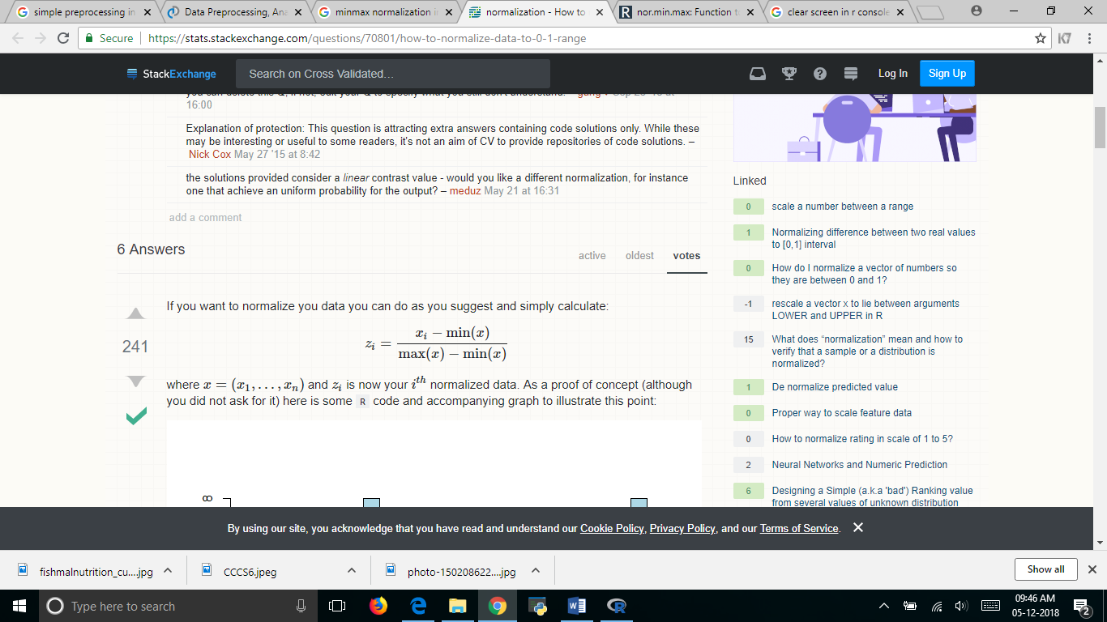

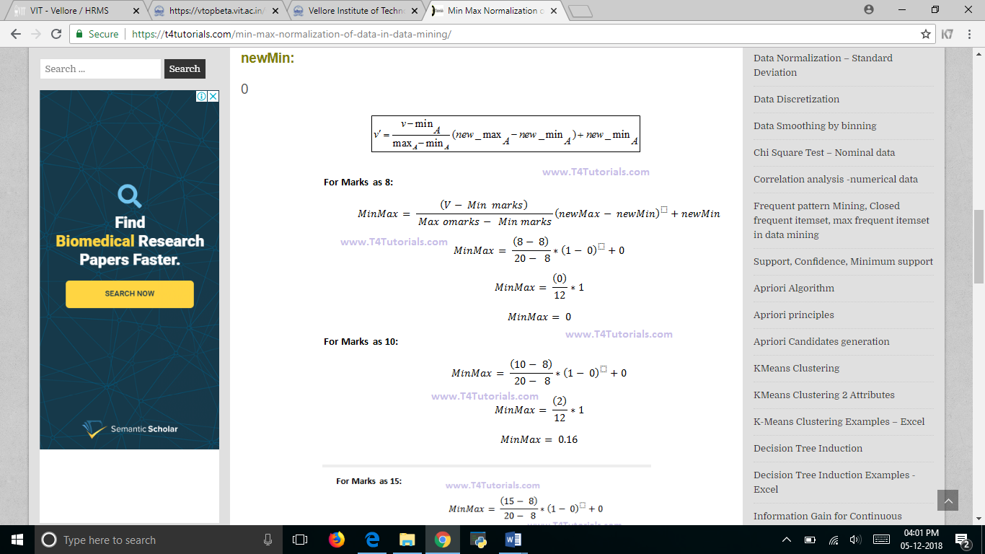

**# Python code to Rescale data (between 0 and 1)**

import pandas as pa

import numpy as np

from sklearn.preprocessing import MinMaxScaler

names = ['preg', 'plas', 'pres', 'skin', 'test', 'mass', 'pedi', 'age', 'class']

dataframe =pa.read_csv(“C:/Users/Admin/Desktop/pima.csv”, names=names)

dataframe.head()

array = dataframe.values

**# separate array into input and output components**

X = array[:,0:8]

Y = array[:,8]

min= MinMaxScaler(feature_range=(0, 1))

scal= min.fit(X)

rescaledX=scal.transform(X)

**# summarize transformed data**

np.set_printoptions(precision=3)

print(rescaledX[0:5,:])

**Z score normalization:**

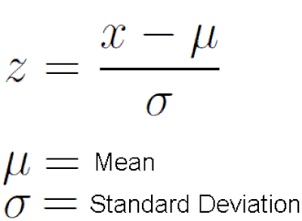

**# Python code to Standardize data (0 mean, 1 stdev)**

from sklearn.preprocessing import StandardScaler

import pandas as pa

import numpy as np

names = ['preg', 'plas', 'pres', 'skin', 'test', 'mass', 'pedi', 'age', 'class']

dataframe =pa.read_csv(“C:/Users/Admin/Desktop/pima.csv”, names=names)

dataframe.head()

array = dataframe.values

**# separate array into input and output components**

X = array[:,0:8]

Y = array[:,8]

scaler = StandardScaler()

rescaledX = scaler.fit_transform(X)

**# summarize transformed data**

np.set_printoptions(precision=3)

print(rescaledX[0:5,:])